**Policy Review Cover Sheet**

|  |  |
| --- | --- |
| **SAFEGUARDING** | |
| **WORK AREA:** | **POLICY NUMBER: RISK 50** |

|  |  |
| --- | --- |
| **Author: Angie Anderson** | **Job Title: Director of Clinical Services** |
| **Owner: Risk Sub Committee** |  |

|  |  |
| --- | --- |
| **Approved by:** | RISK |
| **Implementation Date**  **(new policy):** |  |
| **Date of Next Review:** | **MARCH 26** |

|  |  |
| --- | --- |
| **Review Date** | **Amendments** |
| 05.03.24 | AA amended some website details. |
| 04.06.24 | AA reviewed and amended following Rochdale Borough Council’s two yearly review. Adding in a link directly to their policy and condensing our version. |
|  | Changed all references of Dr Chris Pick to Medical  Director (20.01.25-AA) |

**SAFEGUARDING POLICY**

**SPRINGHILL HOSPICE**

**POLICY DERIVED BY THE RISK GROUP**

Previously, Springhill Hospice Safeguarding policy was an adapted version of the Rochdale Borough Safeguarding Adults Board (RBSAB) and Rochdale Borough Safeguarding Childrens Partnership (RBSCP) policy.

The Safeguarding Boards updated their policy in October 2023 and the revised comprehensive version is available on their website. In order to conform with locality policy and procedures and ensure that we have the most up to date guidance, the link to the website is included within this Hospice policy. Where our policy varies due to organisational requirements, these are included within our policy in more detail.

The detail which forms the policy is accessible via the RBSAB website and sections can be downloaded: <https://rochdalesafeguarding.com/p/resources-and-tools/multi-agency-policy-procedures-protocols-and-guidance>

**To report an Adult Safeguarding concern please contact:**

**Adult Care on 0300 303 8886 Monday to Friday 8.30am to 4.45pm,**

**or 0300 303 8875 at all other times,**

**or email a Safeguarding concerns form to adult.care@rochdale.gov.uk.**

**If there is immediate danger or someone needs urgent medical attention call the emergency services (999)**

**If you think a criminal offence has been committed inform the police on 101**

**Further safeguarding information is available at** [**www.rochdalesafeguarding.com**](http://www.rochdalesafeguarding.com)

# RBSAB and RBSCP policy content

<https://rochdalesafeguarding.com/p/resources-and-tools/multi-agency-policy-procedures-protocols-and-guidance>

|  |  |
| --- | --- |
| **Section** | **Content** |
|  | Policy |
|  | Glossary |
|  | What is Abuse and Neglect   * Example of abuse * Who abuses and neglects? * Spotting signs of abuse and neglect |
|  | Carers and Safeguarding |
|  | Legal framework |
|  | Information sharing |
|  | Local roles and responsibilities |
|  | Legal support for victims of crime |
|  | Advocacy in Safeguarding |
|  | Use of interpreters |
|  | Reporting a concern |
|  | Responding to a concern |
|  | Safeguarding Adult reviews |
|  | Resolving Professional Disagreements |
|  | Complaints |

**Springhill Hospice additional or variance from the locality policy**

|  |  |
| --- | --- |
| **Page** | **Content** |
| 3 | Safe Recruitment |
| 4 | Safeguarding Lead; Role and Responsibilities |
| 4 | Sharing Information |
| 5 | What to Do If You Are Concerned About an Adult / Child |
| 5 | Procedure for Raising / Reporting A Concern |
| 8 | Managing Allegations Against Staff and Volunteers |
| 9 | Induction, Training and Supervision |
| 9 | Safeguarding Statement |
| 9 | Safeguarding Contact Details |
| 10 | Appendix 1: Safeguarding Statement |
| 11 | Appendix 2: What to Do If Abuse Is Suspected |

# Aim

Safeguarding is everyone’s business. Springhill Hospice believes that it is always unacceptable for adults, young people and children to experience abuse of any kind and recognises its responsibility to safeguard the welfare of all adults at risk in line with the Care Act (2014) and Children’s Act (1989 / 2004). The aim of this policy is to ensure that the Springhill Hospice safeguards the welfare of adults, young people and children who may be at risk and are able to recognise the signs and respond appropriately to allegations of abuse. We aim to achieve this by ensuring that Springhill Hospice complies with statutory and local guidance for safeguarding and promoting the welfare of children, young people and adults at risk by creating a safe environment**.**

# Scope of this policy

This policy and procedure apply to all Springhill Hospice staff, volunteers and visitors whose work brings them into contact with adults, young people and children that may be at risk of abuse or neglect.

# Springhill Hospice practice (specific to local practice)

# Safe Recruitment

Springhill Hospice have appropriate systems and procedures in place to ensure the safe recruitment of all staff and volunteers within the organisation who come into contact with adults, young people and children. This should include requirements set out by the Disclosure and Barring Service (DBS).

* Recruitment Policy.
* Training in safer recruitment.
* Evidence of DBS checks being completed.
* Evidence (where required) of overseas worker checks being completed as per Home Office requirements

Refer to Springhill Hospice policies; Recruitment policy; Volunteer recruitment and management policy; Secure storage, handling, use, retention and disposal of DBS disclosures and Disclosure information.

NB: Where appropriate refer to appropriate Professional Bodies requirements i.e. NMC, GMC.

# Safeguarding Lead, Roles and Responsibilities

The Safeguarding Lead for Springhill Hospice is the Hospice Medical Director who has day to day responsibility for safeguarding across Springhill Hospice including:

* To act as an ambassador for Springhill Hospice in the capacity of adults at risk.
* To provide leadership on all aspects of adults at risk within Springhill Hospice.
* To champion safeguarding within Springhill Hospice ensuring that it has a high profile within the organisation.
* To advise volunteers and staff within Springhill Hospice on safeguarding issues (including implementation of policy, working with service users, development of services, policy developments – both national, regional and local developments, service audits etc).
* To keep Springhill Hospice staff/volunteers updated on relevant safeguarding issues/policy updates via email/other means of information dissemination.
* To act as an information source on safeguarding and to assist Springhill Hospice staff/volunteers with identification of key contacts/networks within the field of safeguarding/ adults at risk.
* To keep up to date on any changes to policy and new policies, which could affect the different service areas of Springhill Hospice.
* To attend any relevant multi agency safeguarding forums as required.

# Sharing information

Sharing information is an essential part of effective safeguarding practice. It allows multiple staff and / or agencies to build a complete picture of a situation where one individual or agency would be unable to do so. Often it is only when information from a number of sources is shared that it becomes clear that an adult, young person or child is at risk of harm. This then enables early intervention and prevention work to be carried out.

***Confidentiality*** and ***consent*** are two key issues and are clarified below. For more information, see the Springhill Hospice Confidentiality policy and Consent policy.

***Confidential information*** is information which is personal, sensitive, not already lawfully in the public domain, and shared in confidence or the reasonable expectation of confidence.

Confidential information may be shared with the consent of the person who provided it or to whom it relates.

Confidential information may also be shared ***without consent under the following circumstances:***

* If there is evidence or reasonable cause to believe that an adult, child or young person is suffering or at risk of suffering significant harm, or of causing significant harm to themselves or others.
* Where an individual 16 years and over lacks capacity to consent supported by the Mental Capacity Act (2005)
* To prevent significant harm to children and young people.

***Photography and Surveillance*** is the use of technology to take either still or live visual recordings of a person or environment. Care Quality Commission (CQC) has issued guidance for providers and reference should also be made to the organisations Photography and Surveillance Policies and Procedures. Please refer to: Information management and security policy.

# What to Do If You Are Concerned About an Adult / Child

Where staff have concerns about the safety of an adult / child, staff should report these concerns to the organisations Safeguarding Lead (Medical Director). Should the Medical Director not be available, the concern should be reported to the senior Doctor or Registered Manager (Director of Clinical services) and a referral made to either Adult Social Services or Children’s Social Services.

In the event that there are immediate concerns for the safety of the adult or child or it is felt that a crime may have been committed then a referral to the Police must take place via 999 or 101 depending on the situation.

The Registered Manager (Director of Clinical Services) must be informed as it may require notification to the CQC.

**Procedure for Raising / Reporting A Concern**

**To make a safeguarding referral**

A referral may be made by phone to Adult Care or the Emergency Duty Team (0300 303 8886 Monday to Friday from 8.30am to 4.45pm, or 0300 303 8875 at all other times), email **a Safeguarding concern form to** adult.care@rochdale.gov.uk

https://rochdalesafeguarding.com/p/resources-and-tools/multi-agency-policy-procedures-protocols-and-guidance

**If an adult is in immediate danger ring 999**

Contact the Safeguarding team to discuss the concern initially then complete the Safeguarding concerns form and email to adult.care@rochdale.gov.uk

The most up to date version form is available on the RBSAB website: https://rochdalesafeguarding.com/p/resources-and-tools/multi-agency-policy-procedures-protocols-and-guidance



Best practice is to follow up the referral to establish the outcome and cascade the information to the Hospice staff involved in the patients care.

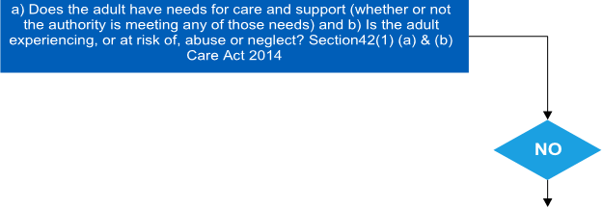

Are you concerned that an adult is at risk of or is experiencing abuse or neglect?

What types of abuse or neglect are you concerned about?

Have you had a conversation with the adult about the concerns?

Have you sought the views and wishes of the adult? *

Are there any immediate risks to the adult or to others including children?

Have you discussed and agreed next steps with the adult? *

Have you provided advice, information or signposted the adult?



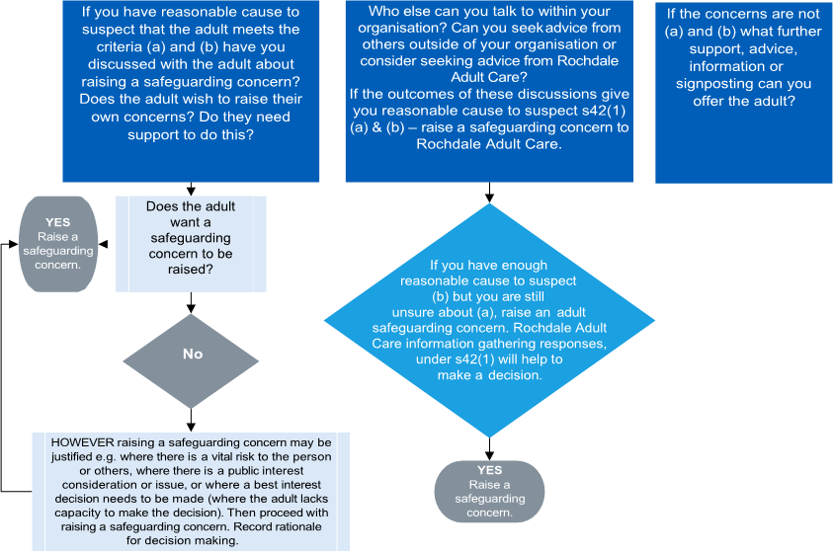

|  |
| --- |
| *There may be circumstances where the safety of the adult or yourself prevent this from happening.  If you still have concerns about abuse or neglect and it is not possible or within the scope of your role to have a conversation with the adult, then if in doubt continue with the process and raise a safeguarding concern. |

# Managing Allegations Against Staff and Volunteers

Where the organisation becomes aware that there are concerns about an employee or volunteer which may not directly involve the adult at risk but may have risk implications that demonstrates a potential unsuitability for working with children, young people and adults at risk. They must follow organisational policy and guidelines for managing concerns / allegations. Refer to Freedom to Speak Up / Raising Concerns (Whistleblowing) policy.

Examples include

* Commitment of a criminal offence against or related to children, young people or adults at risk.
* Behaving towards children, young people or adults, in a manner that indicates they are unsuitable to work with this client group.
* Where an allegation or concern arises relates to the individuals’ private life such as perpetration of domestic abuse; behaviours to his/her own children; or behaviour to others which may impact upon the safety of children/adults to whom they owe a duty of care.
* Where inadequate steps have been taken to protect vulnerable individuals from the impact of violence or abuse and neglect.

All concerns and allegations must be considered in line with Local Adult and Local Children’s Safeguarding Partnership Boards and policy relevant to managing allegations against persons who work with children, young people or adults at risk.

Further information and guidance can be found on the RBSAB / RBSCP websites:

<https://rochdalesafeguarding.com/p/resources-and-tools/allegations-management-adults>

**Whistle Blowing**

Should you have concerns about misconduct, illegal acts or failures to carry out duties in a safe manner by any employee including the Registered Manager then staff should refer to the organisations Freedom to Speak up: Raising Concerns (whistleblowing) policy.

**Induction, Training and Supervision**

**Induction**

All Springhill Hospice staff and volunteers receive an induction (as per organisational requirements).

**Training**

All Springhill Hospice staff and volunteers receive mandatory training on joining the organisation; this includes safeguarding adults and children’s training, including training on types of abuse; recognising signs of abuse; duty of reporting; their role in responding to suspected abuse; risk assessment and management.

Safeguarding training is refreshed every three years for all staff and volunteers.

**Supervision**

Springhill Hospice are committed to ensuring that all staff who have contact with adults at risk or children receive an appropriate level of supervision and support. Staff are able to discuss scenarios with their line manager or Safeguarding lead to provide an opportunity to debrief and receive support. There is opportunity for informal or formal reflection and additional support would be accessed appropriate to individual need.

# Safeguarding statement

All services must display the statement for service users on Safeguarding see **Appendix 1** for a copy of the Safeguarding Statement.

# Safeguarding contact details

|  |  |  |
| --- | --- | --- |
| **Service Safeguarding Lead** | **Service Area** | **Contact** |
| Medical Director | Springhill Hospice | 01706 649920 |
| Adult Care | HMR | 0300 303 8886  ***Mon - Fri 8.30am to 4.45pm*** |
| Adult Care | HMR | 0300 303 8875  ***at all other times*** |
| Adult Care | HMR | adult.care@rochdale.gov.uk. |

**Appendix 1: Safeguarding Statement for Springhill Hospice**

Springhill Hospice believes that it is unacceptable for anyone to experience abuse of any kind and recognises its responsibility to safeguarding the welfare of all adults, young people and children by a commitment to practice which protects them.

Abuse may consist of a single act or repeated acts. It may be physical, verbal or psychological, it may be an act of neglect or an omission to act, or it may occur when a vulnerable person is persuaded to enter into a financial or sexual transaction to which he or she has not consented, or cannot consent. Abuse can occur in any relationship and may result in significant harm to, or exploitation of, the person subjected to it.

Abuse of adults at risk, young people or children may be perpetrated by a wide range of people including relatives, family members, professional staff, paid care workers, volunteers, other service users, neighbours, friends and associates, people who deliberately exploit vulnerable people and strangers.

It is not always obvious when someone is being abused, there may be specific signs or your instincts may tell you something is wrong. Abuse is never acceptable in any circumstances and everyone has the right to be safe. Safeguarding adults, young people and children is everyone’s business.

Working in partnership with the community and safeguarding authorities Springhill Hospice aims to make sure that adults at risk using its services are listened to and protected from abuse. Springhill Hospice staff must report all incidents or concerns they have relating to the wellbeing of an adult at risk, young person or child.

Members of the public who have concerns should follow guidance offered by their local Adult Safeguarding Board or Children’s Safeguarding Board.

If you wish to notify or log a safeguarding concern about an adult at risk, young person or child accessing Springhill Hospice you can contact the following:

|  |  |  |
| --- | --- | --- |
| **Service Safeguarding Lead** | **Service Area** | **Contact** |
| **Medical Director** | **Springhill Hospice** | **01706 649920** |
| **Rochdale Borough Council** | **Adult Safeguarding** | **0300 303 8886** |
| **Rochdale Borough Council** | **Children Safeguarding** | **0300 303 0440** |

**Appendix 2: What to do if abuse is suspected**

Staff/volunteers may become concerned that a vulnerable adult is being abused, or is at risk of abuse, as a result of one or more of the following:

* Direct disclosure by a vulnerable adult
* A complaint or expression of concern by another person
* Observing the behaviour of the vulnerable adult
* Evidence of physical abuse

**If abuse is suspected the following action should be taken:**

* 1. Take reasonable steps to ensure the adult is in no immediate danger and seek appropriate medical treatment for the adult if required.
  2. Obtain consent from the vulnerable adult before disclosing confidential information about them.
  3. Where the vulnerable adult is unable to consent, undertake ‘best interest’ assessment, applying the principles of the Mental Capacity Act 2005
  4. Discuss concerns with the Safeguarding Lead (Medical Director), Senior Doctor in their absence, the Registered Manager (Director of Clinical services) or appropriate manager or person responsible for overseeing the care of the vulnerable adult.
  5. The Appropriate Manager must report concerns to the Chief Executive or their Deputy.
  6. Hospice staff should **not** make any further enquiries of the vulnerable adult or of the person/s suspected of abuse at this stage.
  7. If, after discussion, abuse or neglect is still considered to be a possibility an immediate referral by email should be made to the Adult Care Services. The referral form is on Rochdale Borough Safeguarding Adults website.

<https://rochdalesafeguarding.com/p/safeguarding-for-adults/multi-agency-policy-procedures-protocols-and-guidance>

* 1. When completed email it to: [adult.care@rochdale.gov.uk](mailto:adult.care@rochdale.gov.uk)
  2. If it is believed a criminal offence may have been committed, the police need to be contacted immediately (see below for contact details).
  3. Where there is an allegation or instance of abuse, neglect or other harm this should also be reported to the Care Quality Commission.
  4. Should the person suspected of the abuse be a member of hospice staff the Disciplinary procedure will be implemented.
  5. Staff involved should record an accurate account of all that has happened, stating the facts of any injury, times, explanations and action taken.
  6. Staff should document carefully what they have observed and when they observed it. Any signs of physical injury should be described in detail.
  7. Any comment made by the vulnerable adult and the person/s suspected of abuse should be recorded, preferably using the words actually used as soon as possible after the comment has been made.
  8. Acknowledge the specific and individual needs of carers, appropriate to the situation.